CYCLE-5
Q1:LIST VIEW
PROGRAM
Main_activity
package com.example.sjcet.listview;
import android.support.v7.app.AppCompatActivity;
import android.os.Bundle;
import android.widget.ArrayAdapter;
import android.widget.ListView;
public class MainActivity extends AppCompatActivity {
ListView lv;
@Override
protected void onCreate(Bundle savedInstanceState) {
super.onCreate(savedInstanceState);
setContentView(R.layout.activity_main);
lv=(ListView)findViewById(R.id.lv);
String[] courses={"MCA","MBA","BBA","BCA"};
ArrayAdapter adapter = new ArrayAdapter(this,android.R.layout.simple_list_item_1,courses);
lv.setAdapter(adapter);
}
}
Activity.xml
<?xml version="1.0" encoding="utf-8"?>
<android.support.constraint.ConstraintLayout xmlns:android="http://schemas.android.com/apk/res/android"
xmlns:app="http://schemas.android.com/apk/res-auto"
xmlns:tools="http://schemas.android.com/tools"
android:layout_width="match_parent"
android:layout_height="match_parent"
tools:context=".MainActivity">
<TextView
android:id="@+id/textView2"
android:layout_width="wrap_content"
android:layout_height="wrap_content"
app:layout_constraintBottom_toBottomOf="parent"
app:layout_constraintLeft_toLeftOf="parent"
app:layout_constraintRight_toRightOf="parent"
app:layout_constraintTop_toTopOf="parent" />
<TextView
android:id="@+id/textView"
android:layout_width="162dp"
android:layout_height="47dp"
android:layout_marginStart="8dp"
android:layout_marginLeft="8dp"
android:layout_marginEnd="8dp"
android:layout_marginRight="8dp"
android:text="Account"
app:layout_constraintEnd_toEndOf="parent"
app:layout_constraintStart_toStartOf="parent"
tools:layout_editor_absoluteY="64dp" />
<ListView
android:id="@+id/lv"
android:layout_width="368dp"
android:layout_height="321dp"
tools:layout_editor_absoluteX="8dp"
tools:layout_editor_absoluteY="131dp" />
</android.support.constraint.ConstraintLayolistut>
OUTPUT
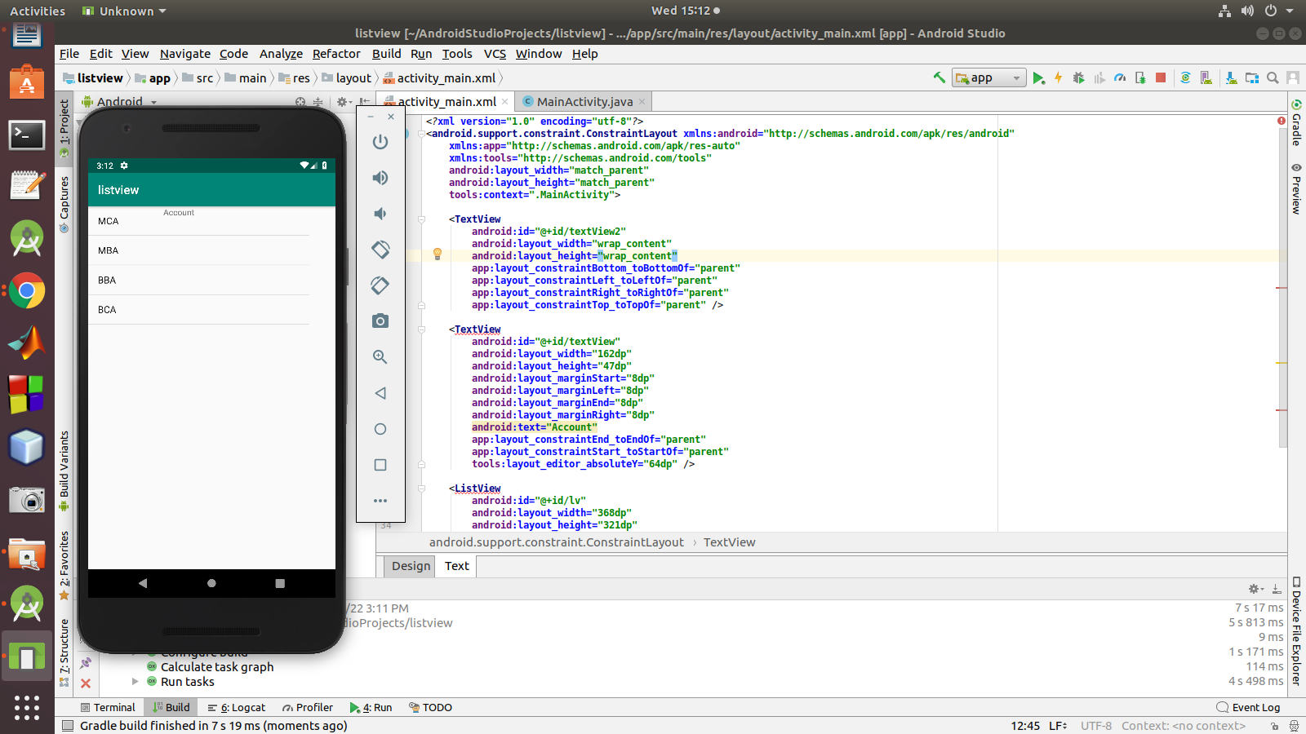

Q2:List View using Toast
program
Activity_Main.xml
<?xml version="1.0" encoding="utf-8"?>
<android.support.constraint.ConstraintLayout xmlns:android="http://schemas.android.com/apk/res/android"
xmlns:app="http://schemas.android.com/apk/res-auto"
xmlns:tools="http://schemas.android.com/tools"
android:layout_width="match_parent"
android:layout_height="match_parent"
tools:context=".MainActivity">
<TextView
android:id="@+id/textView2"
android:layout_width="wrap_content"
android:layout_height="wrap_content"
app:layout_constraintBottom_toBottomOf="parent"
app:layout_constraintLeft_toLeftOf="parent"
app:layout_constraintRight_toRightOf="parent"
app:layout_constraintTop_toTopOf="parent" />
<TextView
android:id="@+id/tv"
android:layout_width="162dp"
android:layout_height="47dp"
android:layout_marginStart="8dp"
android:layout_marginLeft="8dp"
android:layout_marginEnd="8dp"
android:layout_marginRight="8dp"
android:text="Account"
app:layout_constraintEnd_toEndOf="parent"
app:layout_constraintStart_toStartOf="parent"
tools:layout_editor_absoluteY="64dp" />
<ListView
android:id="@+id/lv"
android:layout_width="368dp"
android:layout_height="321dp"
tools:layout_editor_absoluteX="8dp"
tools:layout_editor_absoluteY="131dp" />
</android.support.constraint.ConstraintLayout>
Main_Activity.java
package com.example.sjcet.tostlistview;
import android.content.Intent;
import android.net.Uri;
import android.support.v7.app.AppCompatActivity;
import android.os.Bundle;
import android.view.Menu;
import android.view.MenuItem;
import android.view.View;
import android.widget.AdapterView;
import android.widget.ArrayAdapter;
import android.widget.ListView;
import android.widget.TextView;
import android.widget.Toast;
public class MainActivity extends AppCompatActivity implements AdapterView.OnItemClickListener {
TextView tv;
ListView lv;
@Override
protected void onCreate(Bundle savedInstanceState) {
super.onCreate(savedInstanceState);
setContentView(R.layout.activity_main);
tv=(TextView)findViewById(R.id.tv);
String msg=getIntent().getStringExtra("mykey");// receiving the data
tv.setText("welcome"+msg);
lv=(ListView)findViewById(R.id.lv);// display(welcom changing to admin)
// listvivew operation
String[] courses={"MCA","MBA","BBA","BCA"};
ArrayAdapter adapter = new ArrayAdapter(this,android.R.layout.simple_list_item_1,courses);
lv.setAdapter(adapter);
// attach listener
lv.setOnItemClickListener(this);//implement the method by alt+enter
}
@Override
public void onItemClick(AdapterView<?> adapterView, View view, int i, long l) {
String itemname=lv.getItemAtPosition(i).toString();
Toast.makeText(this,itemname,Toast.LENGTH_SHORT).show();
}
}
OUTPUT
